Ohio Western Dressage Association
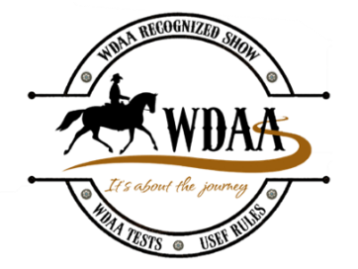
“Too Hot To Trot” Schooling Show
WDAA Recognition # 26-410
AQHA Recognition # 915409
Sunday, August 23, 2026
Closing Date: Saturday, August 8, 2026
Twin Towers Park
501 Yellow Springs Fairfield Rd.
Yellow Springs, OH 45387
USEF “R” Western Dressage Judge
Sara Justice
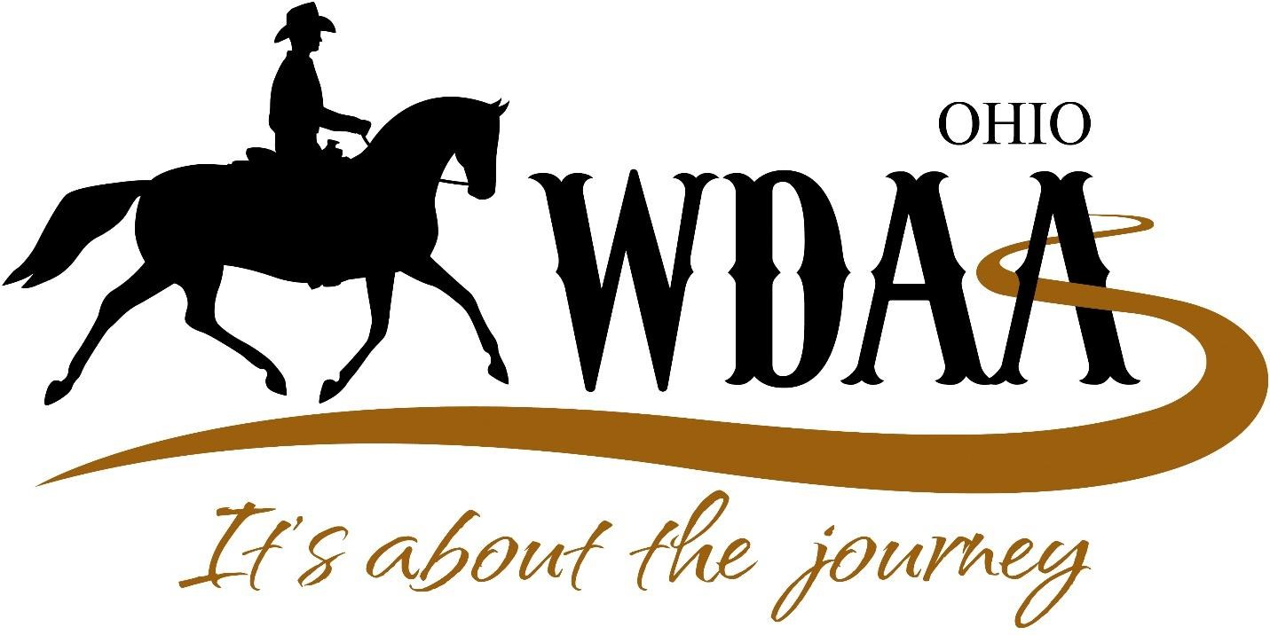

Show Manager/Secretary: Samantha Terry, 937-408-2108
owdariders@gmail.com
All tests and patterns can be found at westerndressageassociation.org
An additional judge and ring will be added if needed

Dress Code: Dress is semi-casual and show clothes are optional. ASTM-approved helmets are encouraged. Due to high temperatures, the Judge may allow short-sleeved collared shirts at her discretion.
Equipment: USEF/WD rules and guidelines will be used for attire and equipment.
Health Requirements:
Out of State Horses: Please ensure you have the appropriate documentation for your horse(s) per the Ohio Department of Agriculture. http://www.agro.ohio.gov
ALL horses from out of state must have a current Coggins Test
Volunteers Always Needed: Contact Candace Carlson ohwdapresident@gmail.com . Lunch will be provided to volunteers working 4 hours or more.

Fees
(No refunds after closing date.)
Office Fee: $25 per entry (horse/rider combination).
Non-Competing Horse: $25 Plus office fee, stabling, haul-in fees,
Stalls: $25 per day plus $25 deposit. $50 for Saturday and Sunday, plus $25 deposit. $75 for Friday, Saturday and Sunday, plus $25.00 deposit. Deposit is refundable once stall has been cleaned. Limited number of stalls available. Stalls will be assigned on a first come served basis. No Tack Stalls Available.
Haul-in: $10 (Horses not having a stall).
AQHA Fee: $10.00
Late Entry Fee: $10 if post marked after Closing Date – August 8, 2026.
Returned check fee: $50
Post Office Visit Fee: $20 will be added to your mailed entry if it requires a signature.
Judge’s scores are final: Show management reserves the right to combine, split or cancel classes as needed.
Exceptional Riders: Must submit a completed WDAA Statement of Eligibility for Exceptional Rider Classes. This applies to both Physically Challenged and Therapeutic Riders.
Show Office: Will be open Saturday 3-7 pm, and from 7am Sunday until an hour after the show closes.

Facility/Test/Entry Information
Facility: All tests will be ridden in a 20X60 outdoor ring, and the ring will be reduced to a 20X40 for the Intro and Basic Levels. The footing is sand. Lunging is only allowed in the designated area. Two rings will be utilized if entries warrant it. Dogs must always be on leashes.
WDAA Dressage Tests: WDAA 2022 version
Divisions:
Junior - Under 18 as of Dec. 1, 2025
Adult Amateur - 18 and over as of Dec. 1, 2025
Open - Professionals, Adult Amateurs and Juniors
Test limit is six per day per horse. This does not include suitability or dressage seat equitation.
Horses can only compete in two consecutive levels.
A horse may be ridden by different riders, but only 6 tests in total. Horse/rider combinations may ride the same test twice at the same competition, given that they are separate class numbers. No horse may be ridden more than once in any Western Dressage class including separate sections of the same class number. Horses may be ridden in junior, amateur and open sections at the same competition. Horses cannot be ridden by more than two riders.

2026 OHWDA Horse Show High Percentage Awards

High Percentage Award: Eligibility for the OHWDA A competitor must ride in at least 3 of the OHWDA 2026 shows. The competitor's top percentage from each show will be added together to determine the average. If a rider has competed in more than 3 shows, their top three scores from different shows will be used, with the lowest score(s) being removed. The awards will be by division: Open, Amateur, Junior, Physically Challenged and Therapeutic.
Further Clarification: A competitor is defined as the same horse and rider combination.

2026 OHWDA End of Year Award Program

The Ohio Western Dressage Association offers a Year End Award Program to current members of OHWDA. An overall highpoint award is awarded in each division and individual level high point awards in each division. Levels: Intro, Basic, Level 1, Level 2, Level 3, Level 4 and Level 5. For more information go to https://www.wdaoh.org/end-of-year-awards

WDAA Awards Programs
YEHP: The WDAA Year-End High Point Program (YEHP) and (IYEHP) is a program that recognizes horses that excel in Western Dressage competition between January 1st through December 31st. Through the YEHP and IYEHP, horses earn points based on their performance at WDAA-recognized shows.
WHLPAP: The WDAA Horse Lifetime Points and Awards Program (WHLPAP) is all about recognizing the growth and accomplishments of the dedicated horses in the program. Share your Journey and track your horse’s Western Dressage career milestones and earn beautiful, customized Lifetime Awards celebrating your horse’s achievements in Western Dressage at WDAA recognized shows.
Get your horse a free ID number and join or renew a membership in WDAA to be included in these two programs. Forms and information about enrolling and earning awards are available here: https://wdaapoints.org/

To Enter:
By Email: – email entry form to owdariders@gmail.com . We will invoice you through PayPal: a 5.0% convenience fee will be added.
Mailed Entry – Only checks or money orders made out to the Ohio Western Dressage Association. Mailed entries must be post-marked by the Closing Date: August 8, 2026.

Class List
Class | Class Name | Divisions
1 | Western Dressage Intro Level - Test 1 | Open/AA/JR
2 | Western Dressage Intro Level - Test 2 | Open/AA/JR
3 | Western Dressage Intro Level - Test 3 | Open/AA/JR
4 | Western Dressage Intro Level - Test 4 | Open/AA/JR
5 | Western Dressage Basic Level – Test 1 | Open/AA/JR
6 | Western Dressage Basic Level – Test 2 | Open/AA/JR
7 | Western Dressage Basic Level – Test 3 | Open/AA/JR
8 | Western Dressage Basic Level – Test 4 | Open/AA/JR
9 | Western Dressage Level One – Test 1 | Open/AA/JR
10 | Western Dressage Level One – Test 2 | Open/AA/JR
11 | Western Dressage Level One – Test 3 | Open/AA/JR
12 | Western Dressage Level One – Test 4 | Open/AA/JR
13 | Western Dressage Level 2– Test of Choice (indicate test) | Open/AA/JR
14 | Western Dressage Level 3– Test of Choice (indicate test) | Open/AA/JR
15 | Western Dressage Level 4– Test of Choice (indicate test) | Open/AA/JR
16 | Western Dressage Level 5 – Test of Choice (indicate test) | Open/AA/JR
17 | Physically Challenged Rider Test of Choice (indicate test) | Open/AA/JR
18 | Therapeutic Rider - Therapeutic Test of Choice (indicate test) | Open/AA/JR

August 23, 2026 Ohio Western Dressage Association Entry Form
Closing Date is August 23, 2026
Only one horse/rider entry per form
Horse’s Name__________________________________ Registration #_________________
Breed_____________________________ Horse’s Sex: M G S Horse ID#____________
circle one:
Rider’s Name _________________________________________WDAA #______________
Rider’s E-mail Address ___________________________ Phone __________________
Rider’s AQHA # (if applicable) ____________________________________________________
Address _______________________________________________________
City, State and Zip _____________________________________________________
Instructor (if they are schooling you) _____________________________________________
Stable with (use one stable group name) _____________________________________
Circle one: Open Amateur Adult Junior
CLASSES ARE: $35 per Dressage Test
Class | Class Description |  | Level | Test | Amount
 |  | Total Class Fees
 |  | AQHA Fee $10.00
 |  | Office Fees
 |  | Stall Fees
 |  | Refundable Stall Deposit
 |  | Non-competing Horse
 |  | Haul-ins
 |  | Total

Make Checks Payable to Ohio Western Dressage Association
Mail entries to OHWDA Schooling Show, 2819 East State Route 29, Urbana, OH 43078
Competitor Signature _______________________________________
Horse Owner’s Signature _______________________________________ Parent/Guardian Signature (If rider is under 18) _____________________________ Questions: Contact Show Secretary: Samantha Terry samanthaterry102@gmail.com or 937-408-2108
All competitors must complete a Ohio Liability Release and Acknowledgement and submit with entry

Ohio Western Dressage Association

OHIO LIABILITY RELEASE AND ACKNOWLEDGEMENT
I AGREE that I chose to participate voluntarily in the Ohio Western Dressage Association Schooling Show and/or Ohio Western Dressage Association or sponsored activities. I am fully aware and acknowledge that horseback riding and equine activities carry inherent dangerous risks of accidents, loss, and serious bodily injury. In accordance with the Ohio Equine Liability Act, Ohio Revised Code 2305.321, I do hereby acknowledge the following INHERENT RISKS OF EQUINE ACTIVITES:
- The propensity of an equine to behave in ways that may result in injury, death or loss to person on or around the equine;

- The unpredictability of an equine’s reaction to sounds, sudden movement, unfamiliar objects, persons, to other animals;

- Hazards, including, but not liable to, surfaces or subsurface conditions;

- A collision with another equine, another animal, a person, or an object;

- The potential of an equine activity participant to act in a negligent manner that may contribute to injury, death, or loss to the person of the participant or to other person, including, but not limited to, failing to main control over an equine or failing to act within the ability of the participant.

IN AGREE THAT: In consideration of the Ohio Western Dressage Association allowing my participation in Ohio Western Dressage Association hosted or sponsored activities, and /or any other equine activity, under the terms set forth herein, I, the rider, and the parent, legal guardian of a minor, do (a) agree to hold harmless and release the Ohio Western Dressage Association, it agents, volunteers, employees, officers, members, premises owners, affiliated organizations, and insurers from legal liability due to any of their negligence or to the negligence or actions of other riders, auditors, clinicians, or spectators, (b) waive legal claim I or my minor child or ward named below may have against Ohio Western Dressage Association, its agents, volunteers, employees, officers, members, premises owners, affiliated organizations, and Insurers for injuries resulting from any INHERENT RISKS OF EQUINE ACTIVITIES, as described above and in Ohio Revised Code 2305.321, and (c) agree that I am participating in all equine activities hosted , organized, or sponsored by the Ohio Western Dressage Association at my own risk and assumes all risk of damage or injury to my person, horse or property other than that due to the intentional misconduct of the Ohio Western Dressage Association. I understand that this waiver will remain effective unless and until revoked by me in writing. I also agree that the Ohio Western Dressage Association or its agents may terminate an activity at their discretion to maintain a safe, professional, and organized environment.
I understand and have read this Release/ Agreement and agree to its content
Rider’s Signature: ________________________________________________
(If the rider is a minor, this must be signed by the rider’s parent or legal guardian)
Printed Name: ________________________________________________
Minor’s Name: _______________________________________________
Date: _____________________

Ohio Western Dressage Association State Affiliate Membership Form

Name: _______________________________________________ WDAA Number:___________
Spouse/Parent: _________________________________________________________________
Farm Name: ___________________________________________________________________
Address: ______________________________________________________________________
City: _____________________ State: ____________________ Zip Code: _________________
Day Phone: ______________________________ Evening Phone: ________________________
Date of Birth: _______________ Email Address: ______________________________________
___________________________________________________________________________
Please read each membership type carefully: New member Renewal Member
Are you (circle one) Professional Amateur Youth Student
Membership Options: (Membership 1/1/2025-12/31/2025)
_____Single Membership $20 (Must be a member of WDAA to join OHWDA) WDAA#__________
_____ Veteran Membership $15 (Must be a member of WDAA to join OHWDA) WDAA#__________
_____ Junior Membership $10 (Must be a member of WDAA to join OHWDA) WDAA#__________
_____ Awards Program - $30 per horse and rider combination, Score must be submitted to the awards Chairperson.
Horses Name: _____________________________________________
Riders Name: ______________________________________________
(Use back of form for additional horses and riders)
_____ Total Membership Fees: Make Checks Payable/PayPal to Ohio Western Dressage Association

Mail to: Ohio Western Dressage Association
2819 East State Route 29, Urbana, OH 43078
Email to: ohiowesterndressageassociation@gmail.com

